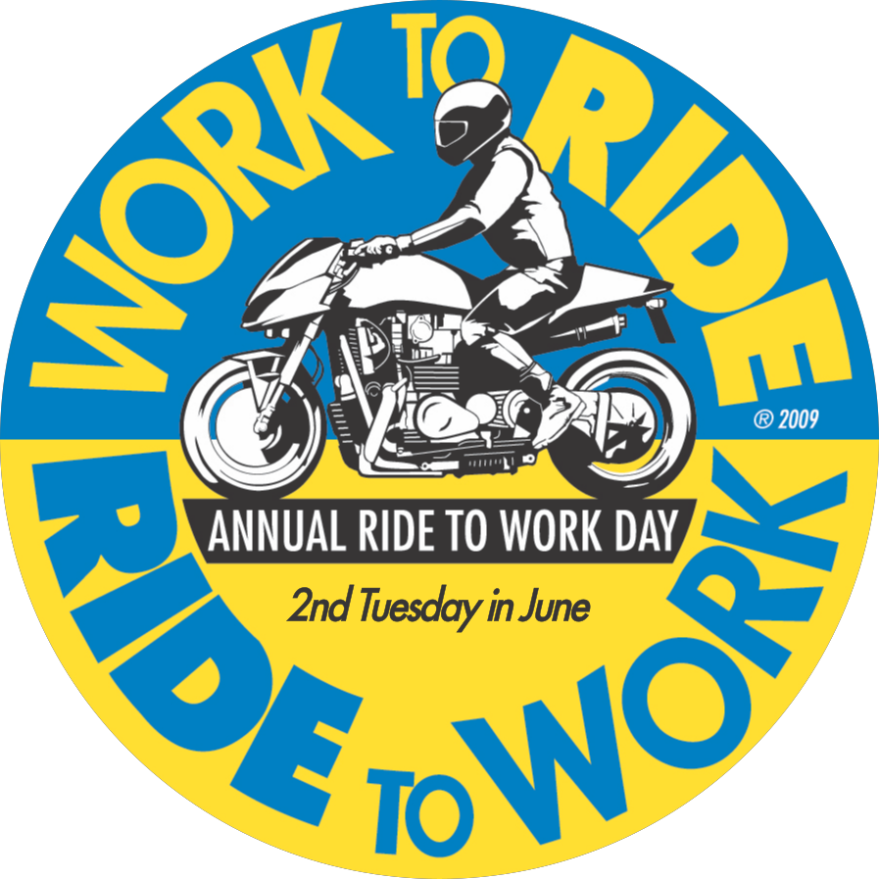

Dear Mayor,

This year the 33rd annual Motorcycle and Scooter Ride to Work Day is Tuesday, June 11th. Over a million workers will commute with their motorcycles and scooters to demonstrate the societally positive benefits of these vehicles.

Your administration can encourage this popular grass-roots event with an official proclamation of support. To encourage riding on this day, some cities also announce that these vehicles may park at all municipal ramps and metered spaces without charge.

Studies have shown the public benefits of motorcycle and scooter commuting include:

- Providing increased parking spaces for everyone else, because several fit in each space.
- Consuming fewer resources per mile per commuter than automobiles.
- Reducing traffic congestion and saving travel time for everyone.
- Riders are more alert and engaged than drivers arriving at work via automobile.

Motorcycle and scooter riders seek government and employer support for riding’s broad benefits. Over 150 American cities have already proclaimed support for Ride to Work Day (See www.ridetowork.org for a list and .pdf’s of the proclamations).

Ride to Work Day is a popular way to showcase this socially responsible (and enjoyable) form of utility transportation. I hope our city will formally join hundreds of groups, organizations, and other cities worldwide already supporting the annual Ride to Work Day.

Sincerely,

Community Ride to Work Day organizer

